Fall Protection Systems and Falling Object Protection - Criteria and Practices of
Walking-Working Surfaces Training Material and Comprehension Quiz

- Policy
  - The management ensures that any fall protection system and falling object protection other than personal fall protection systems meet the standards.
  - The management ensures that each personal fall protection system complies with the requirements as much as possible.
  - Romero’s Food Products Inc. provides and installs all fall protection systems and falling object protection as required and complies with the other requirements before any employee begins work that necessitates fall or falling object protection.

- Procedure
  - Guardrail systems
    - Top rail is 42 inches, +/- 3 inches above the walking/working level.
    - Midrail is located midway between the top rail and the walking/working level;
      - Install mid rails at a height midway between the top edge of the guardrail system and the walking-working surface.
      - Extend screens and mesh from the walking-working surface to the top rail and along with the entire opening between top rail supports.
      - Install intermediate vertical members (such as balusters) no more than 19 inches (48 cm) apart.
      - Install other equivalent intermediate members (such as additional mid rails and architectural panels) so that the openings are not more than 19 inches (48 cm) wide.
    - The top rail can withstand a force of 200 pounds when applied in any downward or outward direction.
    - Ensure the top rail of the guardrail system does not deflect to a height of less than 39 inches (99 cm) above the walking-working surface.
    - Mid rails can withstand a force of 150 pounds applied in any downward or outward direction.
    - Ensure guardrail systems are smooth-surfaced to protect employees from injuries, such as punctures or lacerations, and to prevent catching or snagging of clothing.
    - Make sure the ends of the top rails and mid rails do not overhang the terminal posts, except where the overhang does not pose a projection hazard for employees.
    - Prohibit the use of steel banding and plastic banding for top rails or mid rails.
    - Top rails and mid rails are at least 0.25-inches (0.6 cm) in diameter or thickness.
    - When guardrail systems are used at hoist areas, a removable guardrail section, consisting of a top rail and mid rail, is placed across the access opening between guardrail sections when employees are not performing hoisting operations.
    - When guardrail systems are used around holes, they are installed on all unprotected sides or edges of the hole.
    - For guardrail systems around holes when materials are being passed through the hole,
      - Not more than two sides of the guardrail system are removed and;
      - The hole is guarded by a guardrail system along all unprotected sides or edges or closed over with a cover.
    - When guardrail systems are used around holes that serve as points of access (such as ladderways), the guardrail system opens:
      - Has a self-closing gate that slides or swings away from the hole and is equipped with a top rail and mid rail or equivalent intermediate member; and
      - Is offset to prevent an employee from walking or falling into the hole.
    - Install guardrail systems on ramps and runways along each unprotected side or edge.
    - Inspect Manila or synthetic rope used for top rails or mid rails as necessary to ensure that the rope continues to meet the strength required.

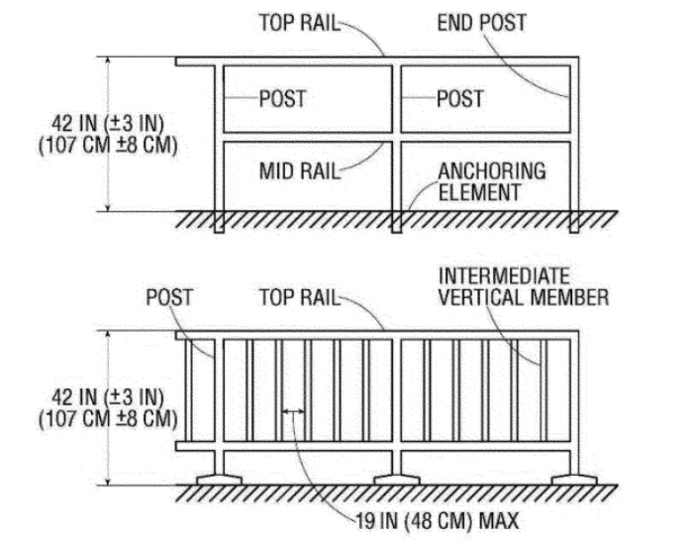
Figure D-11 Guardrail Systems

  - Safety net systems
    - Each safety net system meets the requirements in 29 CFR part 1926, subpart M.
  - Designated areas
    - When designated area is used:
      - Ensure employees remain within the designated area while work operations are underway; and
      - Make sure the perimeter of the designated area is delineated with a warning line consisting of a rope, wire, tape, or chain.
    - The warning line:
      - Has a minimum breaking strength of 200 pounds (0.89 kN);
      - Is installed so its lowest point, including sag, is not less than 34 inches (86 cm) and not more than 39 inches (99 cm) above the walking-working surface;
      - Is supported in such a manner that pulling on one section of the line does not result in slack being taken up in adjacent sections causing the line to fall below the limits specified in paragraphs (d)(2)(ii) of this section;
      - Is visible from 25 feet (7.6 m) away, and anywhere within the designated area;
      - Is erected as close to the work area as the task permits; and
      - Is erected not less than 6 feet (1.8 m) from the roof edge for work that is both temporary and infrequent, or not less than 15 feet (4.6 m) for other work.
    - When mobile mechanical equipment is used to perform work that is both temporary and infrequent in a designated area, the warning line is erected not less than 6 feet (1.8 m) from the unprotected side or edge that is parallel to the direction in which the mechanical equipment is operated, and not less than 10 feet (3 m) from the unprotected side or edge that is perpendicular to the direction in which the mechanical equipment is operated.
  - Covers
    - Each cover for a hole in a walking-working surface:
      - Is capable of supporting without failure, at least twice the maximum intended load that may be imposed on the cover at any one time; and
      - Is secured to prevent accidental displacement.
  - Handrails and stair rail systems
    - Height criteria.
      - Handrails are not less than 30 inches (76 cm) and not more than 38 inches (97 cm), as measured from the leading edge of the stair tread to the top surface of the handrail (see Figure D-12 of this section).
      - The height of stair rail systems installed:
        - Before January 17, 2017, is not less than 30 inches (76 cm) from the leading edge of the stair tread to the top surface of the top rail; and
        - On or after January 17, 2017, is not less than 42 inches (107 cm) from the leading edge of the stair tread to the top surface of the top rail.
      - The top rail of a stair rail system may serve as a handrail only when:
        - The height of the stair rail system is not less than 36 inches (91 cm) and not more than 38 inches (97 cm) as measured at the leading edge of the stair tread to the top surface of the top rail (see Figure D-13); and
        - The top rail of the stair rail system meets the other handrail requirements
    - Finger clearance, minimum clearance between handrails and any other object is 2.25 inches (5.7 cm).
    - Surfaces are smooth surfaced.
    - No opening in a stair rail system exceeds 19 inches (48 cm) at its least dimension.
    - Handrails have the shape and dimension necessary so that employees can grasp the handrail firmly.
    - The ends of handrails and stair rail systems do not present any projection hazards.
    - Strength criteria
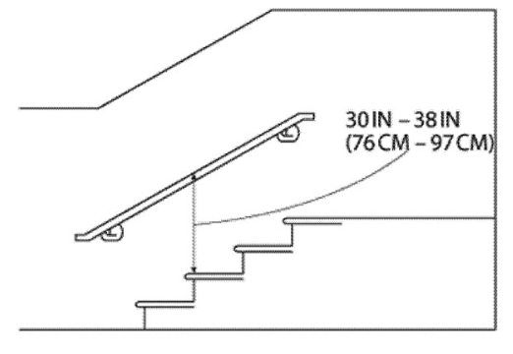
      - Handrails and the top rails of stair rail systems are capable of withstanding, without failure, a force of at least 200 pounds (890 N) applied in any downward or outward direction within 2 inches (5 cm) of any point along the top edge of the rail.
Figure D-12-Handrail Measurement
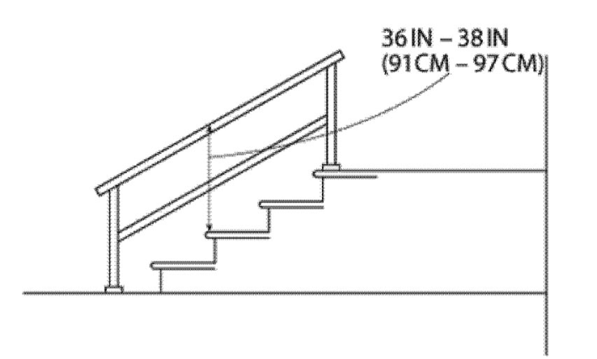
Figure D-13 -- Combination Handrail and Stair Rail
  - Cages, wells, and platforms used with fixed ladders
    - Install cages and wells on fixed ladders are designed, constructed, and maintained to permit easy access to, and egress from, the ladder that they enclose (see Figures D-14 and D-15 of this section);
    - Ensure cages and wells are continuous throughout the length of the fixed ladder, except for access, egress, and other transfer points.
    - Design, construct, and maintain cages and wells to contain employees in the event of a fall, and to direct them to a lower landing; and
    - Provide platforms used with fixed ladders with a horizontal surface of at least 24 inches by 30 inches (61 cm by 76 cm). Figure D-14-Clearances for Fixed Ladders in Wells

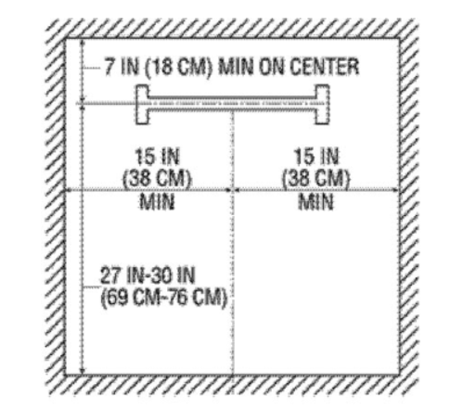

Figure D-14-Clearances for Fixed Ladders in Wells

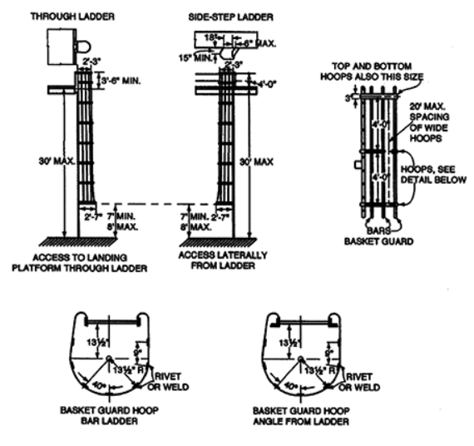
Figure D-15 -- Example of General Construction of Cages

  - Outdoor advertising:
    - Is physically capable, as demonstrated through observations of actual climbing activities or by a physical examination, of performing the duties that may be assigned, including climbing fixed ladders without fall protection;
    - Has completed a training or apprenticeship program that includes hands-on training on the safe climbing of ladders and is retrained as necessary to maintain the necessary skills;
    - Has the skill to climb ladders safely, as demonstrated through formal classroom training or on-the-job training and performance observation; and
    - Performs climbing duties as a part of routine work activity.
  - Ladder safety systems
    - Each ladder safety system allows the employee to climb up and down using both hands and does not require that the employee continuously hold, push, or pull any part of the system while climbing.
    - The connection between the carrier or lifeline and the point of attachment to the body harness or belt does not exceed 9 inches (23 cm).
    - Attach mountings for rigid carriers at each end of the carrier, with intermediate mountings spaced, as necessary, along the entire length of the carrier so the system has the strength to stop employee falls.
    - Attach mountings for flexible carriers at each end of the carrier and cable guides for flexible carriers are installed at least 25 feet (7.6 m) apart but not more than 40 feet (12.2 m) apart along the entire length of the carrier.
    - Ensure the design and installation of mountings and cable guides do not reduce the design strength of the ladder.
    - Ladder safety systems and their support systems are capable of withstanding, without failure, a drop test consisting of an 18-inch (41-cm) drop of a 500-pound (227-kg) weight.
  - Personal fall protection systems.
    - Ensure body belts, harnesses, and other components are used in personal fall arrest systems, work positioning systems, and travel restraint systems.
  - Protection from falling objects
    - The management ensures toe boards are used for falling object protection:
      - Erected along the exposed edge of the overhead walking-working surface for a length that is sufficient to protect employees below.
      - Have a minimum vertical height of 3.5 inches (9 cm) as measured from the top edge of the toe board to the level of the walking-working surface.
      - Do not have more than a 0.25-inch (0.5-cm) clearance or opening above the walking-working surface.
      - Are solid or do not have any opening that exceeds 1 inch (3 cm) at its greatest dimension.
      - Have a minimum height of 2.5 inches (6 cm) when used around vehicle repair, service, or assembly pits. Toe boards may be omitted around vehicle repair, service, or assembly pits when the employer can demonstrate that a toe board may prevent access to a vehicle that is over the pit.
      - Are capable of withstanding, without failure, a force of at least 50 pounds (222 N) applied in any downward or outward direction at any point along the toe board.
    - Install screens to the top rail and for a length that is sufficient to protect employees below.
    - Check that the canopies used for falling object protection are strong enough to prevent collapse and to prevent penetration by falling objects.
  - Grab handles
    - Is not less than 12 inches (30 cm) long;
    - Is mounted to provide at least 3 inches (8 cm) of clearance from the framing or opening; and
    - Is capable of withstanding a maximum horizontal pull-out force equal to two times the maximum intended load or 200 pounds (890 N), whichever is greater.

- Responsibility
  - Romero’s Food Products Inc. has legal responsibility for compliance with occupational safety and health standards.
    - Environmental Health & Safety (EHS)
      - Develops, implements, and manages the Fall Protection and Falling Object Protection program.
      - Audits for compliance and evaluates implementation with this Program and the applicable OSHA standards.
      - Ensures that fall protection devices/systems meet current OSHA regulations.
      - Assists departments in identifying areas/activities that require fall protection.
      - Develop training programs on the recognition of fall hazards.
      - Determines if there are feasible engineering controls that can eliminate the fall hazard.
      - Stops work that poses a clear and imminent danger to the health and safety of the facility.
      - Maintains employee training records.
    - Facilities Planning and Construction
      - Notifies the Environmental Health and Safety office during the design stage of new buildings or renovations of existing buildings that require fall protection installations (i.e., roof edge guarding, skylight protection, cabling systems, etc.).
      - Ensures that the appropriate fall protection measures identified by the EHS Office are incorporated into the design of new buildings and renovations of older buildings.
      - After completion of projects that have had fall protection equipment/systems installed:
        - Obtains vendor/manufacturer certification.
        - Provides vendor/manufacturer training to the employees using the equipment; and
        - Notifies Facilities Operations of the installation(s) of fall protection equipment.
      - Provide documentation of certifications and training to EHS.
    - Employees
      - Complies with the requirements of this program.
      - Conducts inspections of fall protection equipment.
      - Reports equipment defects and issues promptly to supervisors.
      - Complies with fall protection methods.

- Corrective Action
  - Retraining is conducted:
    - When employees are proven with inadequacy in the knowledge of this program
    - Where changes in fall protection usage are necessary due to technological changes of newly purchased fall protection equipment, or specific changes for fall protection usage occur;
    - Changes in the workplace render previous training obsolete.
  - Any damaged components are removed from service immediately.

- Review - Quality
  - Review the general requirements for the development of rules and regulations.
  - Training records are kept by the supervisor and retained for the duration of employment.
  - A review of these general requirements is conducted periodically.

- History
Revision No.: | Revision Date: | Description of Change: | Originator / Author Name: | Title / Department:
0 | 20240105 | Original | Arnel Ryan | PCQI/ Compliance
1 | 20241113 | - Changed email from rfp@interlinkiq.com to rfp@consultareinc.com  - Added Program Title to Comprehension Quiz section | Arnel Ryan | PCQI/ Compliance

Requirements:
- The trainee has read or received a verbal translation of all or part of the policy, procedure, method, and/or SOP for which they are being trained.
- The trainee has demonstrated the task they are to perform or the procedure for which they are being trained as required.
- The trainee has demonstrated the ability to perform the task with acceptable proficiency and minimal supervision.

TRAINEE (Print Name): | TRAINEE (Signature): | Date: | Department:
Trainer / Supervisor (Print Name): | Trainer (Signature): | Date: | Department:

UPON COMPLETION – EMAIL TO rfp@consultareinc.com

NAME (Print): | Date:

Fall Protection Systems and Falling Object Protection - Criteria and Practices of Walking-Working Surfaces Comprehension Quiz

Direction: Choose the best answer and encircle the letter.
- Who ensures that the appropriate fall protection measures identified by the EHS Office are incorporated into the design of new buildings and renovations of older buildings?
    - Environmental Health & Safety (EHS)
    - Facilities Planning and Construction
    - Employees

- Each safety net system meets the requirements in ____________.
- 29 CFR part 1926, subpart M
- 29 CFR part 1929, subpart M
- 29 CFR part 1928, subpart B

- For finger clearance, the minimum clearance between handrails and any other object is 2.28 inches (6.6 cm).
- True
- False

- The provided platforms are to be used with fixed ladders that have a horizontal surface of at least ________.
- 23 inches by 31 inches
- 61 inches by 76 inches
- 24 inches by 30 inches

- Management ensures that any fall protection system and falling object protection other than personal fall protection systems meet the standards.
- True
- False

UPON COMPLETION – EMAIL TO rfp@consultareinc.com

